Simple Queries:

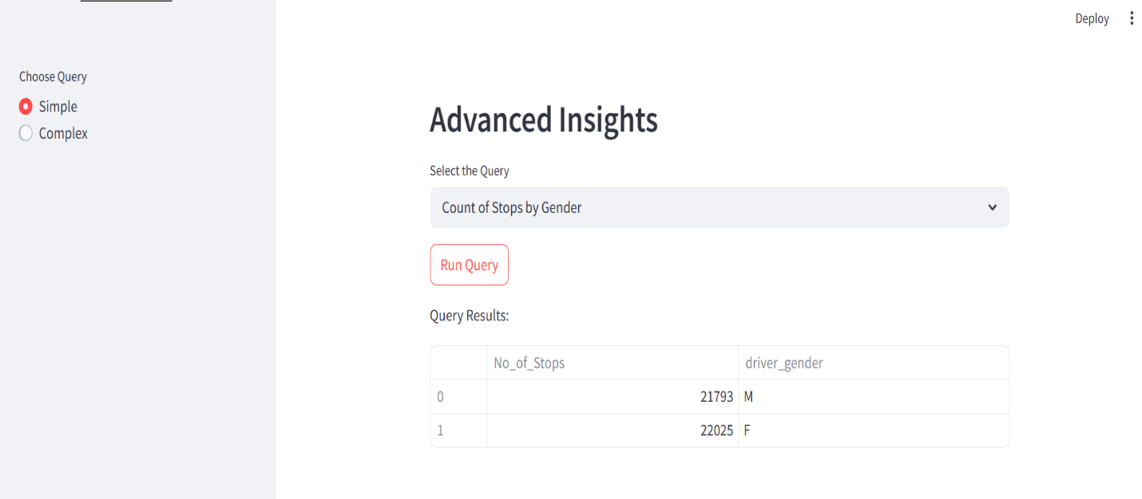

Complex Queries:

Prediction form:

Graph :

